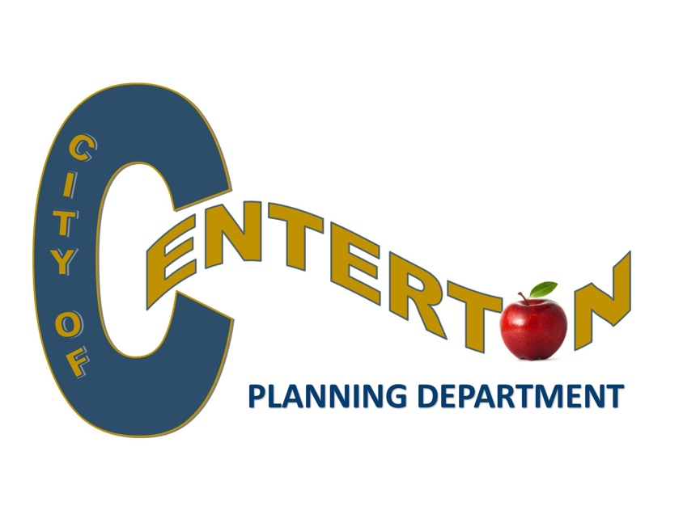
Career Opportunity
The Planning Department
has an immediate opening for an
Experienced City Planner

Seeking qualified person with municipal planning experience
to review various planning & zoning applications including
subdivision & new development submittals for code compliance;
coordinate with developers, engineers, & city staff; and
prepare and present project reports to the Planning Commission.
Must be proficient in Microsoft Office, and possess general clerical,
organizational, & adept oral/written communications skills.

Application at www.centertonar.us
or visit https://www.indeed.com/job/city-planner-ii-d68ba3ac5fa95752
Great benefits include Health insurance & APERS retirement plan.
OPEN UNTIL POSITION FILLED

SUBMIT RESUMES and SALARY REQUIREMENTS TO careers@centertonar.us

City of Centerton is an equal opportunity employer

