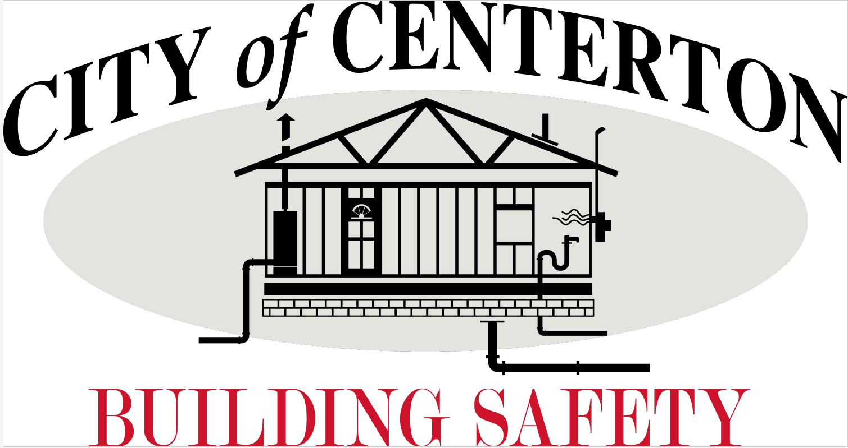
Career Opportunity
The Building & Safety Dept. has an immediate opening for a
Building Inspector

Will perform inspections to assure that all new residential & commercial construction & facilities conform to all building codes, municipal codes, & that existing structures, properties & facilities, and their uses conform to building codes & municipal codes.

*** Applicant must be capable of learning/using BSA software proficiently as well as Microsoft systems such as email, excel, word etc.***

Great benefits include Health insurance & APERS retirement plan.

OPEN UNTIL POSITION FILLED
How to Apply!
contact Human Resources for a full job description
careers@centertonar.us or 479-795-2750 ext. 104
City of Centerton is an equal opportunity employer

