NOW HIRING!

HOW TO APPLY!!
Email - careers@centertonar.us
OR
Contact Human Resources Dept.
200 Municipal Dr, Centerton, AR 72719
Ph. 479-795-2750 ext. 104
FOR CERTIFIED POLICE OFFICERS CENTERTON POLICE DEPARTMENT

Competitive Pay
Start at $20.31/hr ($44,357/yr) with limited experience
Pay increased based on experience

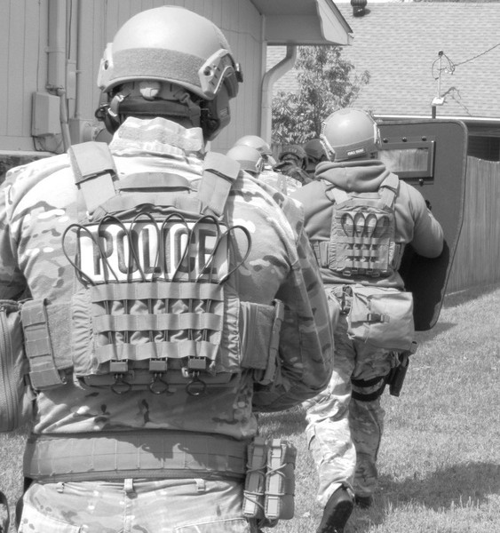
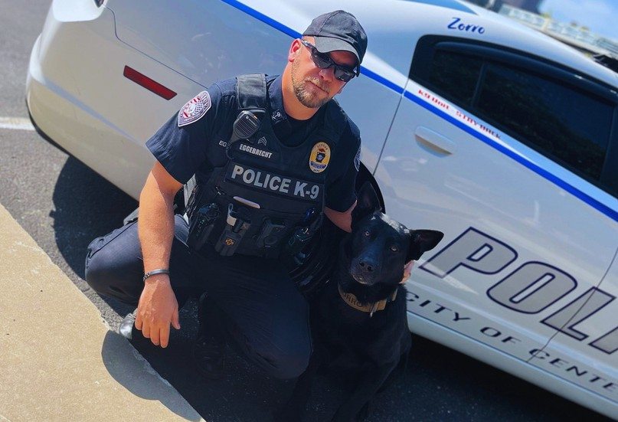
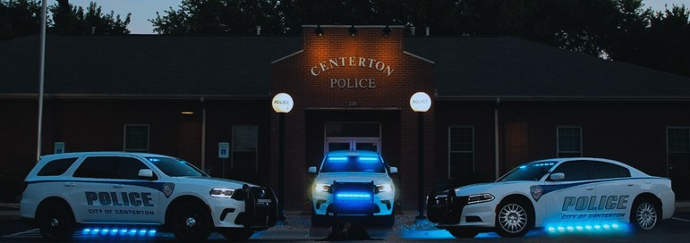
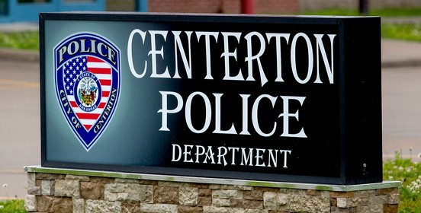
Incentives
12 hour shifts
Take home vehicle program Uniforms paid by Department Lateral transfer program Visible tattoos allowed
Outer vest carrier option Overtime opportunities Approved facial hair policy

Specialties:
K9, SWAT, Bike Patrol, SRO, CID, FOP, Tuition Assistance Available
City pays 8 hours a day for 12 holidays per year LOPFI (Officers contribution is 3.5%)
LOPFI (City contributes 24.50%)
$1/hr Bilingual pay 4% merit raise yearly
Paid in Full:
Individual Health, Dental, and Vision Plans

Certificate Pay
0.28/hr for select certificates

Minimum Requirements
At least 21 years of age A United States Citizen No Felony Convictions
No Domestic violence-related convictions
At least a minimum of High School Diploma or GED A valid driver's license

